Báo cáo lập trình hướng đối tượng

Bài 6.1:

Bài 6.2:

Bài 6.3:

Bài 6.4

Kết quả:

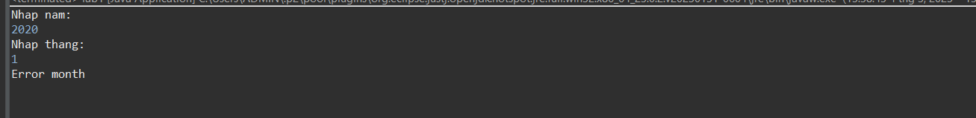

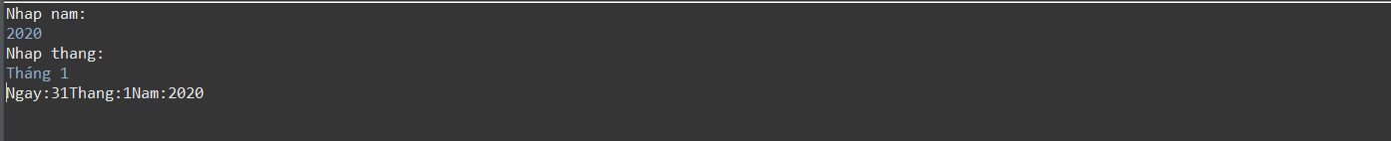

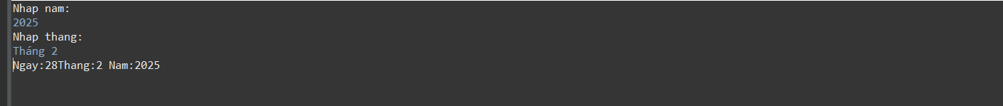

Bài 6.5:

Bài 2.5:

Bài 2.6:

-Kết quả:



